MeFit User Manual

**Contents**

MeFit 2

Login page 2

Goals page 3

Dashboard page 3

Archived goal page 4

Exercise page 4

Workout page 4

Program page 4

Profile page 4

MeFit

MeFit is an application for managing and planning your workout. This applications lets you choose exercises to put in your workouts for your programs and apply a goal for it. Purpose of this applications is to motivate and structure your workouts. It gives some pre made programs and you can create your own.

Login page

Start application by typing *npm start*. This will take you to: <http://localhost:3000>. If you’re not logged in yet, you will be redirected to the login page. Otherwise you will be redirected to the start page.

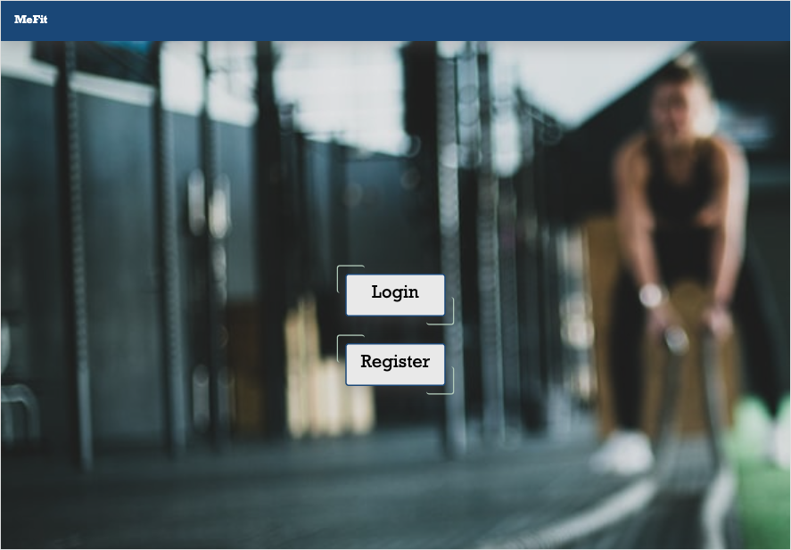

If it’s your first time visiting the website you can register by clicking the register button. Here you will be asked to enter some information, namely: your first name, last name, email, a username (which you can use to log in) and a password.

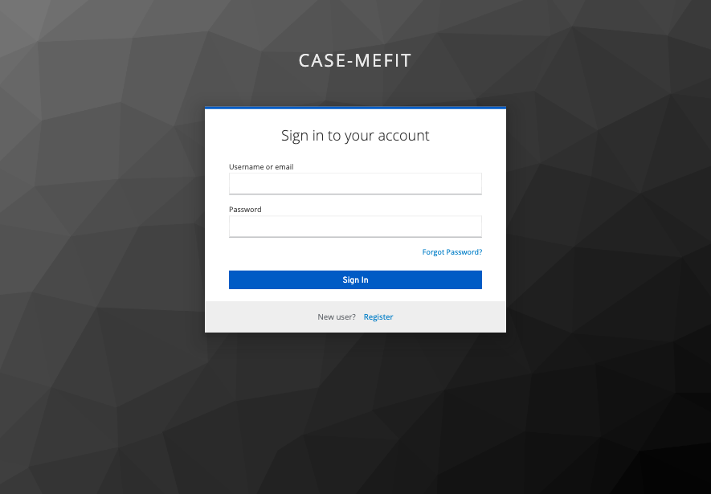

If you’re already register on the website you can log in by entering your username/email and password.

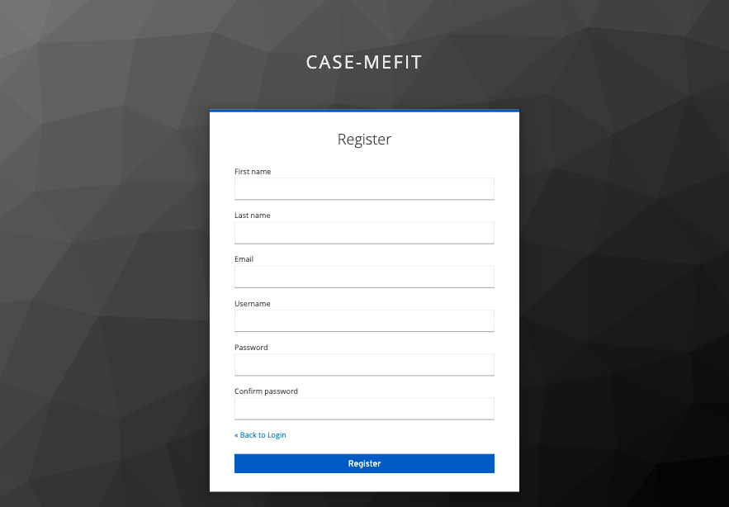

Goals page

The goals page will show your goals for today, the week and you progress to achieve them. Also a list of all you goals.

Dashboard page

Dashboard will list all your goals. If you don’t have any goals yet there’s a button that redirect you to set goals.

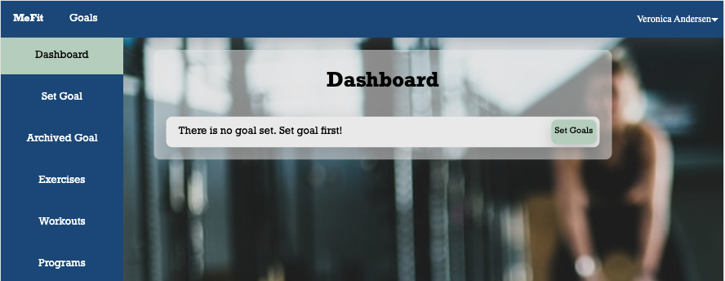

Archived goal page

This page shows goals that has been achieved. This will help you to get more motivated and work towards your big goal.

Exercise page

This page contains a list of all exercises and it also allows you to create your own exercises. This page will allow you to create a new set that you will need to add it to a workout. These exercises can you easily add to your workout with a set connected to it. Each exercise can easily be edited if you want to customize it to your needs.

Workout page

Workout page contains a list of all workouts and also allows you to create your own. These workouts can easily be added to a program. Just specify which program that you will add it to and click add. Each workout can easily be edited if you want to customize it to your needs.

Program page

Program page contains a list of all programs and also allows you to create your own. Each program can easily be edited if you want to customize it to your needs.

Profile page

Profile page contains your personal data. This data will help to check if the goals that has been set up are reasonable. You can easily edit this data.